CSI 5342 Assignment 14.1

By: Matthew Tuan and Robbie Dutton

The first step in specifying a location-aware role-based access control (LRBAC) model is to update our RBAC model from Assignment 13.1 to incorporate the Location class:

The class and associations are based on the model developed in “LRBAC: A Location-Aware Role-Based Access Control Model” which incorporates locations with Users, Roles, Permissions, and Objects.

**Impact of Location on Role Hierarchies and SSD/DSD constraints**

Role Hierarchies contain a Senior-Junior relationship where the Senior roles can inherit the permissions of Junior roles or activate a Junior role. In the paper “A Spatio-Temporal Role-Based Access Control Model”, they outline 8 different hierarchical constraints based on unrestricted and restricted permission inheritance. Focusing only on the location-based constraints in definitions 11 and 12, we will add location restricted permission inheritance and location restricted activation constraints as follows:

Next looking at SSD constraints, we need to ensure that a user cannot be assigned two roles that have SSD constraints while also taking into account the location of the user.

Testing out the new constraint we have 2 script tests: InvalidSSDLocationTest.x and ValidSSDLocationTest.x. These basic files test out a basic session with one user, two roles, and two locations. When a user is assigned two roles with SSD constraints and when the locations overlap the invariant fails. We can see a successful state when the user only has one role assigned and does not have an SSD conflict.

DSD constraints also need to be updated to ensure conflicting roles with the same location cannot be activated in the same session.

Moving forward, we next started to update the CheckAccess operation in Session class. Before that however, we needed to update and add a few constraints to our model. The first one below is quite similar to the previous model, however with LRBAC, we had to add the check that the user’s current location was the same as the role’s assigned location. The rest stayed the same for that.

Next, we added another pre condition for a role to a session.

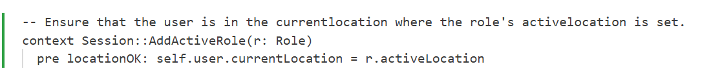

Quite similar to previously, we also needed to check the location was correct for the user’s session. So this was added as well. Next we also created a new association for SessionLocation between one location and many sessions at that said location.

To further this, we updated the User::CreateSession() post conditions, to now link a user session

Lastly, we can now update the Session::CheckAccess() operation.

To start off, we get all the roles unioned into a set. We first check the location of the role is valid for the user’s current location. Next, for each role, we then make sure some of the original attributes are valid, like that the object and operation are correct. Lastly, we should ensure that the user’s location is allowed by the roles permission and same goes for the object’s current location.  
  
To test this all out, we created a test file called `lrbac-valid.x`, this results in the following object diagram.

In the example above, we basically just created one of each type of object and created their associations. Now, to test this out, we just run the following command by calling the session’s CheckAccess operation.  
  
For this next test, we wanted to make sure a user with a different current location, than the object’s current location, would result in a false when returning from the Session::CheckAccess(). Below was the model generated via the ‘lrbac-invalid.x’ file.

Running a test on this produce the correct result of false!

**Summary of each member’s contribution**